Agenda Item : 2/12

= application site



6 Crest View, Pinner | P/1498/18

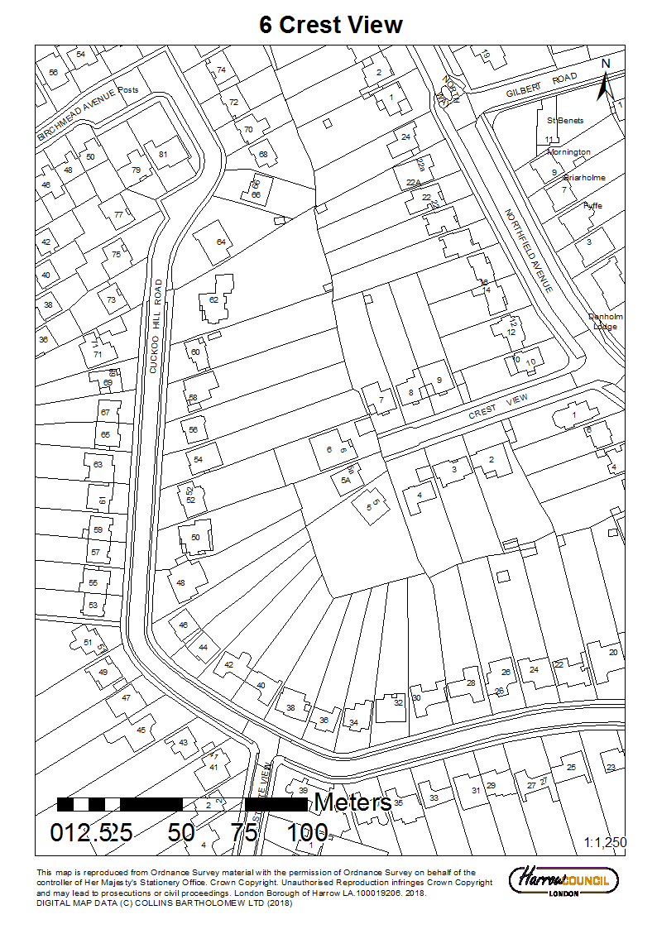

6 Crest View, Pinner | P/1498/18

LONDON BOROUGH OF HARROW

PLANNING COMMITTEE

30th May 2018

APPLICATION NUMBER: | P/1498/18
VALIDATE DATE: | 12/04/2018
LOCATION: | 6 CREST VIEW
WARD: | PINNER
POSTCODE: | HA5 1AN
APPLICANT: | MS JEAN LAMMIMAN
AGENT: | N/A
CASE OFFICER: | KATIE PARKINS
EXPIRY DATE: | 4TH JUNE 2018

PURPOSE OF REPORT/PROPOSAL

The purpose of this report is to set out the Officer recommendations to the Planning Committee regarding an application for planning permission relating to the following proposal:

Single storey front conservatory extension; external alterations.

The Planning Committee is asked to:

- Agree the reasons for approval as set out in this report, and

- GRANT planning permission subject to the Conditions listed in Appendix 1 of this report.

REASON FOR THE RECOMMENDATION

The proposed development would accord with relevant policy and the proposed development would have a satisfactory impact on the character of the area, the amenities of existing neighbouring occupiers.

For these reasons, weighing up the development plan policies and proposals, and other material considerations including comments received in response to notification and consultation, this application is recommended for grant.

INFORMATION

This application is reported to Planning Committee as the application involves development on land in which a member has an interest and therefore falls outside Part 1 (C.iii) of the Scheme of Delegation.

Statutory Return Type: | E21: Householder Development
Council Interest: | None
GLA Community Infrastructure Levy (CIL) Contribution (provisional): | Not applicable  Not applicable  Not applicable
Local CIL requirement: | Not applicable

HUMAN RIGHTS ACT

The provisions of the Human Rights Act 1998 have been taken into account in the processing of the application and the preparation of this report.

EQUALITIES

In determining this planning application the Council has regard to its equalities obligations including its obligations under section 149 of the Equality Act 2010.

For the purposes of this application there are no adverse equalities issues.

S17 CRIME & DISORDER ACT

Policies 7.3.B and 7.13.B of The London Plan and Policy DM1 of the Development Management Polices Local Plan require all new developments to have regard to safety and the measures to reduce crime in the design of development proposal. It is considered that the development does not adversely affect crime risk.

LOCAL GOVERNMENT (ACCESS TO INFORMATION) ACT 1985
BACKGROUND PAPERS USED IN PREPARING THIS REPORT:

- Planning Application
- Statutory Register of Planning Decisions
- Correspondence with Adjoining Occupiers
- Correspondence with Statutory Bodies
- Correspondence with other Council Departments
- Nation Planning Policy Framework
- London Plan
- Local Plan - Core Strategy, Development Management Policies, SPGs
- Other relevant guidance

LIST OF ENCLOSURES / APPENDICES:

Officer Report:
Part 1: Planning Application Fact Sheet
Part 2: Officer Assessment
Appendix 1 – Informatives
Appendix 2 – Site Plan
Appendix 3 – Site Photographs
Appendix 4 – Plans and Elevations

OFFICER REPORT

PART 1: Planning Application Fact Sheet

The Site

Address | 6 Crest View, Pinner, HA5 1AN
Applicant | Ms Jean Lammiman
Ward | Pinner
Local Plan allocation | No
Conservation Area | No
Listed Building | No
Setting of Listed Building | No
Building of Local Interest | No
Tree Preservation Order | No
Other | Critical Drainage Area.

PART 2: Assessment

- SITE DESCRIPTION

  - The application property is a bungalow located at the western end of Crest View in Pinner.

  - The dwellinghouse has existing rear extensions and a detached garage located to the front of the property.

  - The north flank wall of No.5A Crest View is angled away from the boundary with No.6 Crest View with a separation distance of approximately 2m.

  - The front building line of the neighbouring property No. 7 Crest View is perpendicular to the front building line of the host dwelling.

  - The southern boundary of the site is shared with No.54 Cuckoo Hill Drive, with its garden space located towards the south of the site. No.52 Cuckoo Hill Drive is located towards the rear of the site.

  - There is a thick vegetation cover along the boundaries of the site.

- PROPOSAL

  - It is proposed to build a single storey conservatory extension to the front elevation of the dwellinghouse.

  - The proposed conservatory would be 3.56m wide and 3.64m deep. It would have a pitched roof with an eaves and ridge height of 2.34m and 3.15m, respectively.

  - In addition, the proposed development includes to infill the existing front porch.

- RELEVANT PLANNING HISTORY

  - A summary of the relevant planning application history is set out in the table below:

Ref no. | Description | Status and date of decision
HAR/9100 | ERECTION OFHOUSE | GRANTED  (10/05/1954)
HAR/9100/A | ERECTION OF BUNGALOW AND GARAGE | GRANTED  (25/03/1955)

HAR/9100/B | ERECTION OF BUNGALOW AND GARAGE | GRANTED  (10/02/1956)
LBH/291 | ERECTION OF DETACHED BUNGALOW/GARAGE | WITHDRAWN
LBH/291/1 | ERECTION OF DETACHED BUNGALOW GARAGE | GRANTED  (09/02/1966)
LBH/291/2 | EXTENSION TO LOUNGE | GRANTED  (18/05/1970)
LBH/16730 | ERECTION OF SINGLE STOREY EXTENSION TO REAR OF BUNGALOW | GRANTED  (11/04/1980)
P/0471/12 | DETACHED OUTBUILDING IN REAR GARDEN | WITHDRAWN
P/0945/12 | DETACHED OUTBUILDING IN REAR GARDEN | GRANTED  (16/06/2012)
P/2583/17 | FIRST FLOOR REAR EXTENSION WITH JULIETTE BALCONY TO CREATE PART TWO STOREY DWELLING; FOUR ROOFLIGHTS IN FRONT AND TWO ROOFLIGHTS IN REAR ROOFSLOPES; ENCLOSURE OF FRONT PORCH | GRANTED  (08/09/2017)
P/3774/17 | SINGLE STOREY FRONT CONSERVATORY EXTENSION; EXTERNAL ALTERATIONS | REFUSED  (26/10/2017)  Reason for refusal:  The proposal due to its siting and its inappropriate design would result in a prominent and incongruous addition to the property which would not harmonise with the original dwellinghouse, resulting in a detrimental impact to its character and appearance, contrary to the high design aspirations of the National Planning Policy Framework (2012), policies 7.4.B and 7.6.B of The London Plan (2016), policy CS1.B of The Harrow Core Strategy (2012), Policy DM1 of the Harrow Development Management Policies Local Plan (2013) and the adopted Supplementary Planning Document Residential Design Guide (2010).

- CONSULTATION

  - A total of 5 consultation letters were sent to neighbouring properties regarding this application.

  - The overall public consultation period expired on 03/05/2018.

  - Adjoining Properties

Number of letters Sent | 5
Number of Responses Received | 1
Number in Support | 0
Number of Objections | 0
Number of other Representations (neither objecting or supporting) | 1

4.4 1 objection was received from an adjoining resident.

4.5 A summary of the response received along with the Officer comments are set out below:

Details of  Representation | Summary of Comments | Officer Comments
Mrs A Harkness  5A Crest View | - Overdevelopment of the site. Enormous extension already granted (P/2583/17).  - Have recently built a shed which is causing a disturbance due to noise.  - Finished building would not be practical or attractive looking from the street.  - The residents do not use the garage and due to parking restrictions in Crest View, the disruption and inconvenience caused to other residents will be intolerable. | Noted. Impact to character and appearance is discussed in Section 6.2 Character and Appearance of the Area, below.  Please note that due to the siting of the proposed conservatory extension it would not affect the ex

  - Statutory and Non Statutory Consultation

  - No statutory and non-statutory consultations were required for this scheme.

  - External Consultation

  - No external consultation was required for this scheme.

- POLICIES

5.1 Section 38(6) of the Planning and Compulsory Purchase Act 2004 requires that:

‘If regard is to be had to the Development Plan for the purpose of any determination to be made under the Planning Acts, the determination must be made in accordance with the Plan unless material considerations indicate otherwise.’

5.2 In this instance, the Development Plan comprises The London Plan 2016, The Harrow Core Strategy 2012 [CS], Harrow and Wealdstone Area Action Plan (AAP) 2013, the Development Management Policies Local Plan 2013 [DMP], the Site Allocations Local Plan SALP 2013 [SALP].

5.3 While this application has been principally considered against the adopted London Plan (2016) policies, some regard has also been given to relevant policies in the Draft London Plan (2017), as this will eventually replace the current London Plan (2016) when adopted and forms part of the development plan for the Borough.

5.4 The document has been published in draft form in December 2017. Currently, the Mayor of London is seeking representations from interested parties/stakeholders, before the draft Plan is sent to the Secretary of State for Examination in Public, which is not expected to take place until the summer of 2019. Given that that the draft Plan is still in the initial stages of the formal process it holds very limited weight in the determination of planning applications.

5.5 Notwithstanding the above, the Draft London Plan (2017) remains a material planning consideration, with relevant polices referenced within the report below and a summary within Informative 1.

6.0 ASSESSMENT

6.1 The main issues are;

  - Character and Appearance of the Area
  - Residential Amenity - Neighbouring Occupiers
  - Development and Flood Risk

  - Character and Appearance of the Area

6.2.1 Paragraph 6.35 of the adopted SPD states “Front extensions have the greatest potential impact on the character and visual amenity of the street scene”. It also states small front porches may be permitted provided that they: reflect and complement the scale, design, quality and pattern of development in the surrounding street scene and relate to and complement the existing architectural design and materials of the existing building”.

6.2.2 The proposal is for the erection of a pitched roof conservatory to the front elevation of the existing dwellinghouse. The existing bungalow has a cross-gable roof, with a gable frontage. The roof of the proposed conservatory would have a gable front and adjoin the roofslope of the main dwellinghouse at the rear. The rear of the extension would no longer have a section of flat roof adjoining the existing building, and would no longer have an awkward relationship with the original house. It is therefore considered that the amendment to the proposed roof design partially addresses the previous reason for refusal of P/3774/17.

6.2.3 The pitched roof is off centre with the window opening and it is therefore considered that the fenestration is poor and the proposed extension would have. Whilst it is acknowledged that the proposal is not of an excellent design, the existing detached garage would partially cover the proposed development to some extent and is therefore considered that the proposed development would, on balance, not have a detrimental impact to the character and appearance of the original property and the surrounding area, due to these site circumstances.

6.2.4 In summary, the proposal would not have a detrimental impact to the character and appearance of the original property and the surrounding area and therefore complies with policies 7.4B and 7.6.B of the London Plan (2016), policy CS1.B of the Harrow Core Strategy (2012), Policy DM1 of the Harrow Development Management Policies (2013) and the adopted SPD: Residential Design Guide (2010).

6.3 Residential Amenity - Neighbouring Occupiers

6.3.1 Policy DM1 seeks to “ensure that the amenity and privacy of occupiers of existing and proposed dwellings are safeguarded.”

6.3.2 The proposed single storey front extension would not project beyond the front building of the original dwellinghouse. Therefore, the proposal would not be visible to the neighbouring property No5a Crest View and therefore would not result in a detrimental impact to their residential amenities.

6.3.3 The front building line of the neighbouring property No. 7 Crest View is perpendicular to the front building line of the host dwelling. The proposed extension would be screened by the existing detached garage located at the front of the application site, and would be located approximately 11m from the flank wall of No.7 Crest View. Therefore, due to the existing structures on site and the relationship with the neighbouring property No.7 Crest View, the proposed development would not appear unduly prominent nor result in a detrimental impact to their residential amenities.

6.3.4 In summary, the proposal is considered to be acceptable in terms of its impact to the residential amenities of neighbouring properties, in accordance to policy 7.6.B of the London Plan (2016), policy DM1 of the Harrow Development Management Policies (2013) and the adopted SPD: Residential Design Guide (2010).

6.4 Development and Flood Risk

6.4.1 The site is located within a Critical Drainage Area, which means that where there is a net increase in development footprint, there is the potential for surface water run-off rates to increase, but is not in a higher risk flood zone.

6.4.2 The Engineering Drainage Section did not raise any objection to the proposed development.

7.0 CONCLUSION AND REASONS FOR REFUSAL

7.1 The proposal to extend the dwellinghouse with a single storey front conservatory extension and external alterations would have a satisfactory impact on the character of the area and to the residential amenities of neighbouring occupiers and would accord with the relevant planning policies.

7.2 For these reasons, weighing up the development plan policies and proposals, and other material considerations including comments received in response to notification and consultation as set out above, this application is recommended for grant

APPENDIX 1: CONDITIONS AND INFORMATIVES

Conditions

Timing

The development hereby permitted shall be begun before the expiration of three years from the date of this permission.

REASON: To comply with the provisions of Section 91 of the Town and Country Planning Act 1990.

Approved Drawing and Documents

The development hereby permitted shall be carried out in accordance with the following approved plans and documents: 2531/PP/01; 2531/PP/02; 2531/PP/03

REASON: For the avoidance of doubt and in the interests of proper planning.

Materials to Match

The materials to be used in the construction of the external surfaces of the extension hereby permitted shall match those used in the existing building.

REASON: To match the appearance of the original dwelling and to safeguard the appearance of the locality.

APPENDIX 2: INFORMATIVES

Informatives

- Policies

The following policies are relevant to this decision:
The National Planning Policy Framework (2012)

The London Plan 2016:
7.4B, 7.6B

The Draft London Plan 2017:
D1, D2

The Harrow Core Strategy 2012:
CS1.B

Harrow Development Management Policies Local Plan 2013:
DM1 Achieving a High Standard of Development
DM10 On Site Water Management and Surface Water Management

Supplementary Planning Document - Residential Design Guide 2010

- Pre-application engagement

Statement under Article 35(2) of The Town and Country Planning (Development Management Procedures) (England) Order 2015.This decision has been taken in accordance with paragraphs 187-189 of The National Planning Policy Framework. Harrow Council has a pre-application advice service and actively encourages applicants to use this service. Please note this for future reference prior to submitting any future planning applications.

3 Party Wall Act

The Party Wall etc. Act 1996 requires a building owner to notify and obtain formal agreement from adjoining owner(s) where the building owner intends to carry out building work which involves:
1. work on an existing wall shared with another property;
2. building on the boundary with a neighbouring property;
3. excavating near a neighbouring building, and that work falls within the scope of the Act.
Procedures under this Act are quite separate from the need for planning permission or building regulations approval.
"The Party Wall etc. Act 1996: explanatory booklet" is available free of charge from: Communities and Local Government Publications, PO Box 236, Wetherby, LS23 7NB. Please quote Product code: 02 BR 00862 when ordering.
Also available for download from the Portal website:
https://www.gov.uk/party-wall-etc-act-1996-guidance

4 Protection of Highway

The applicant is advised to ensure that the highway is not interfered with or obstructed at any time during the execution of any works on land adjacent to a highway. The applicant is liable for any damage caused to any footway, footpath, grass verge, vehicle crossing, carriageway or highway asset. Please report any damage to nrswa@harrow.gov.uk or telephone 020 8424 1884 where assistance with the repair of the damage is available, at the applicants expense. Failure to report any damage could result in a charge being levied against the property.

5 Considerate Contractor Code of Practice

The applicant's attention is drawn to the requirements in the Considerate Contractor Code of Practice. In the interests of minimising any adverse effects arising from building operations, the limitations on hours of working are as follows:
0800-1800 hours Monday - Friday (not including Bank Holidays)
0800-1300 hours Saturday

6 Surface Water Drainage Management

SUDS Surface water run-off should be controlled as near to its source as possible through a sustainable drainage approach to surface water management (SUDS). SUDS are an approach to managing surface water run-off which seeks to mimic natural drainage systems and retain water on or near the site as opposed to traditional drainage approaches which involve piping water off site as quickly as possible. SUDS involve a range of techniques including soakaways, infiltration trenches, permeable pavements, grassed swales, ponds and wetlands. SUDS offer significant advantages over conventional piped drainage systems in reducing flood risk by attenuating the rate and quantity of surface water run-off from a site, promoting groundwater recharge, and improving water quality and amenity. Where the intention is to use soakaways they should be shown to work through an appropriate assessment carried out under Building Research Establishment (BRE) Digest 365.
Support for the SUDS approach to managing surface water run-off is set out in the National Planning Policy Framework (NPPF) and its accompanying technical guidance, as well as the London Plan. Specifically, the NPPF (2012) gives priority to the use of sustainable drainage systems in the management of residual flood risk and the technical guidance confirms that the use of such systems is a policy aim in all flood zones. Policy 5.13 of the London Plan (2016) requires development to utilise sustainable drainage systems unless there are practical reasons for not doing so. Sustainable drainage systems cover the whole range of sustainable approaches to surface drainage management. They are designed to control surface water run-off close to where it falls and mimic natural drainage as closely as possible. Therefore, almost any development should be able to include a sustainable drainage scheme based on these principles.
The applicant can contact Harrow Drainage Section for further information.

APPENDIX 3: SITE PLAN

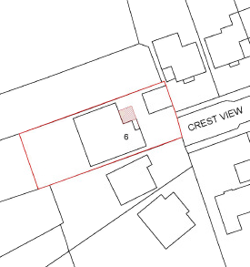
APPENDIX 4: SITE PHOTOGRAPHS

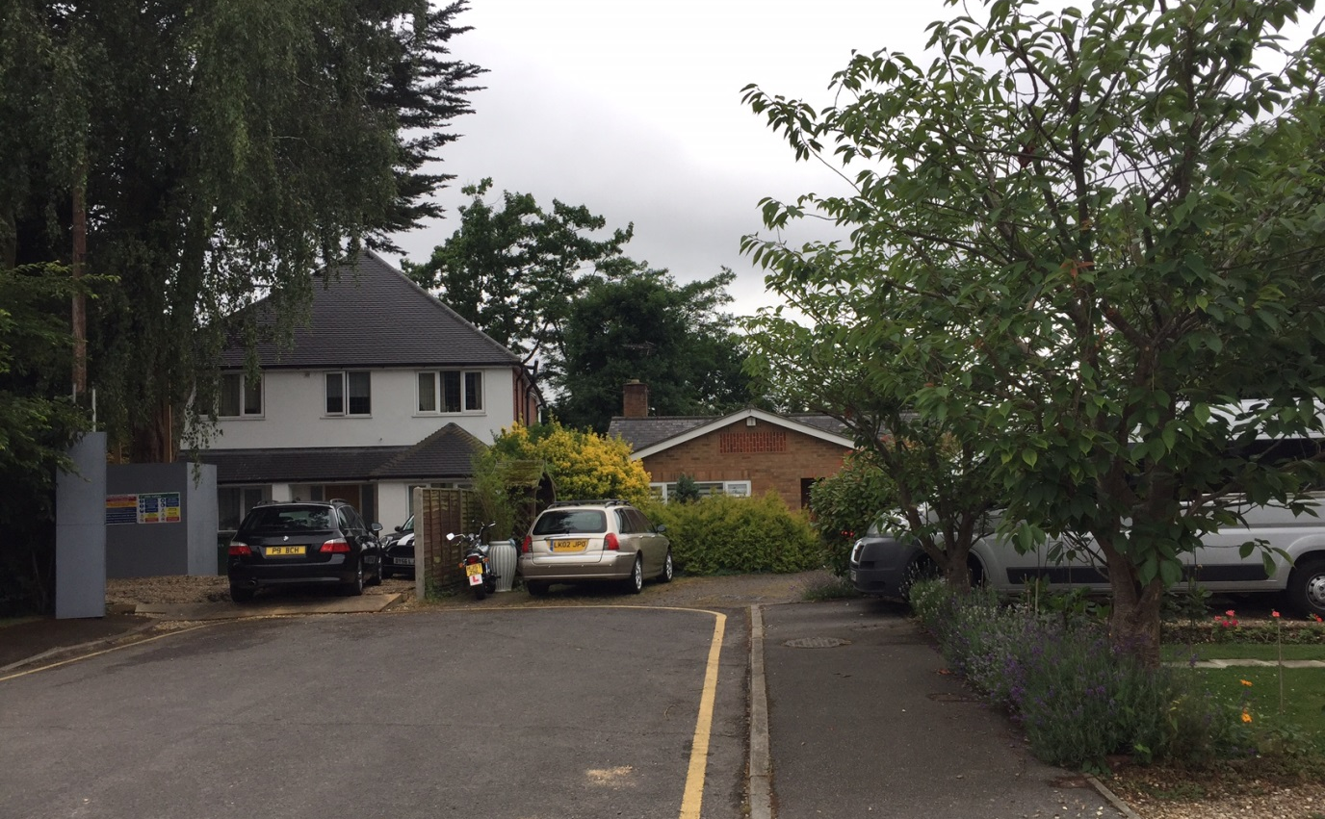

Existing front elevation of the subject property.

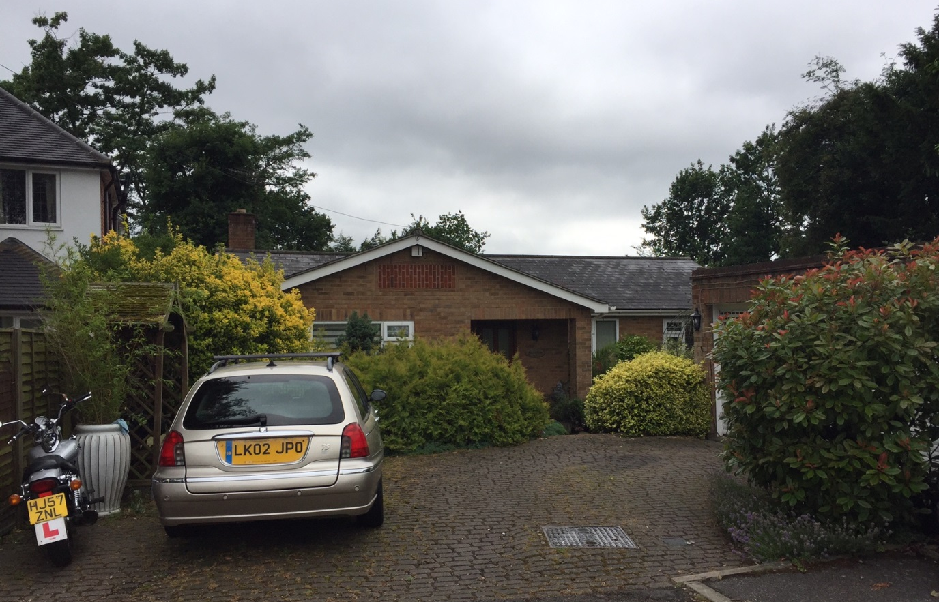

Existing front elevation of the subject property and detached garage, and the neighbouring property No.5a Crest View located to the left.

APPENDIX 5: PLANS AND ELEVATIONS

Existing Elevations

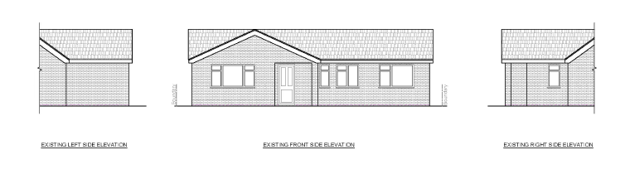

Existing Ground Floorplan

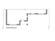

Proposed Elevations

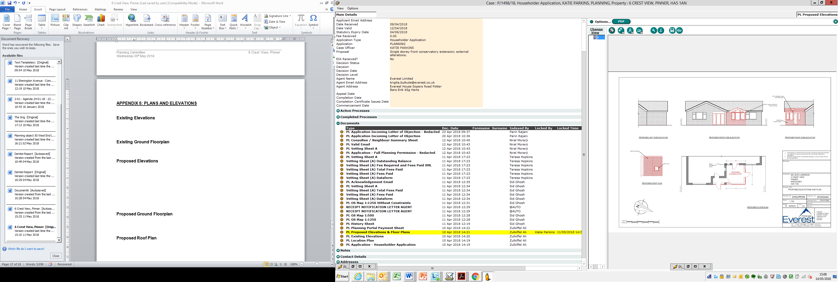

Proposed Ground Floorplan

Proposed Roof Plan

This page has been left intentionally blank

